**IMAGE EDITING**

**NWOKEJI UZOCHUKWU DERIC**

**2023/HND/37759/CS**

**COMPUTER SCIENCE HND1**

**COURSE CODE: SWD 327**

**IMAGE EDITING**

**INTRODUCTION**

Image editing refers to the process of modifying or enhancing digital images using various techniques and tools. This practice is crucial across multiple fields, including photography, graphic design, advertising, and social media. The purpose of image editing is to improve the visual quality of images, correct imperfections, and convey specific messages or emotions.

**HISTORICAL CONTEXT**

The concept of image editing dates back to the early days of photography. In the film era, photographers would physically alter images through techniques such as dodging and burning. With the advent of digital technology, image editing evolved significantly. The introduction of software like Adobe Photoshop in the early 1990s revolutionized the field, making sophisticated editing techniques accessible to a broader audience.

**COMMON TOOLS AND SOFTWARE**

**Adobe Photoshop**: The most widely used image editing software, known for its extensive features including layers, filters, and advanced retouching tools.

**GIMP (GNU Image Manipulation Program)**: A free and open-source alternative to Photoshop, offering many similar capabilities.

**Adobe Light room:** Focused on photo management and enhancement, ideal for adjusting exposure, color balance, and more.

Each tool has its unique strengths and is chosen based on the specific needs of a project.

**BASIC IMAGE EDITING TECHNIQUES**

* **Cropping and Resizing**

***Cropping*** involves cutting out parts of an image to improve composition or focus on a specific area. For example cropping can eliminate distracting backgrounds and highlight the main subject.

***Resizing*** adjusts the dimensions of an image. It’s useful for fitting images into specific formats or reducing file size for web use.

* **Adjusting Brightness and Contrast**

***Brightness*** controls the overall lightness or darkness of an image. Increasing brightness can make an image appear lighter, while decreasing it can add depth.

***Contrast*** affects the difference between light and dark areas. Adjusting contrast can enhance the clarity and detail of an image, making it more visually appealing.

* **Color Correction**

***Saturation*** adjusts the intensity of colors. Increasing saturation makes colors more vibrant, while decreasing it can create a muted effect.

***Hue*** shifts colors along the color spectrum. Correcting hue can help fix color imbalances in an image.

***White Balance*** ensures that colors appear natural under different lighting conditions.

**ADVANCED IMAGE EDITING TECHNIQUES**

* **Layers and Masks**

***Layers*** allow for non-destructive editing by separating different elements of an image. This means changes can be made without permanently altering the original image.

***Masks*** are used to apply edits selectively. For instance, a mask can be used to adjust only the sky in a landscape photo without affecting the foreground.

* **Retouching and Restoration**

***Retouching*** involves removing blemishes, smoothing skin, and correcting imperfections. Tools like the clone stamp and healing brush are commonly used for this purpose.

***Restoration*** focuses on repairing old or damaged photographs. Techniques include color correction, removing scratches, and reconstructing missing parts.

* **Special Effects and Filters**

***Special Effect***s can add creative elements to an image, such as adding a vignette or applying a blur effect. These effects enhance the mood or theme of the image.

***Filters*** provide a quick way to alter the appearance of an image. Popular filters include sepia tones, black-and-white conversions, and artistic effects.

**UNEDITED IMAGE**

An unedited picture captures the scene exactly as it was at the moment it was taken, preserving all the natural elements, colors, and details without any alterations. It serves as an authentic representation of reality, showcasing the true light, shadows, and textures. Unedited images often reveal the photographer’s skill in framing, composition, and timing, highlighting the raw beauty or imperfections of the subject. While editing can enhance or stylize an image, an unedited picture maintains its originality, offering a genuine and often more powerful connection to the moment it depicts.

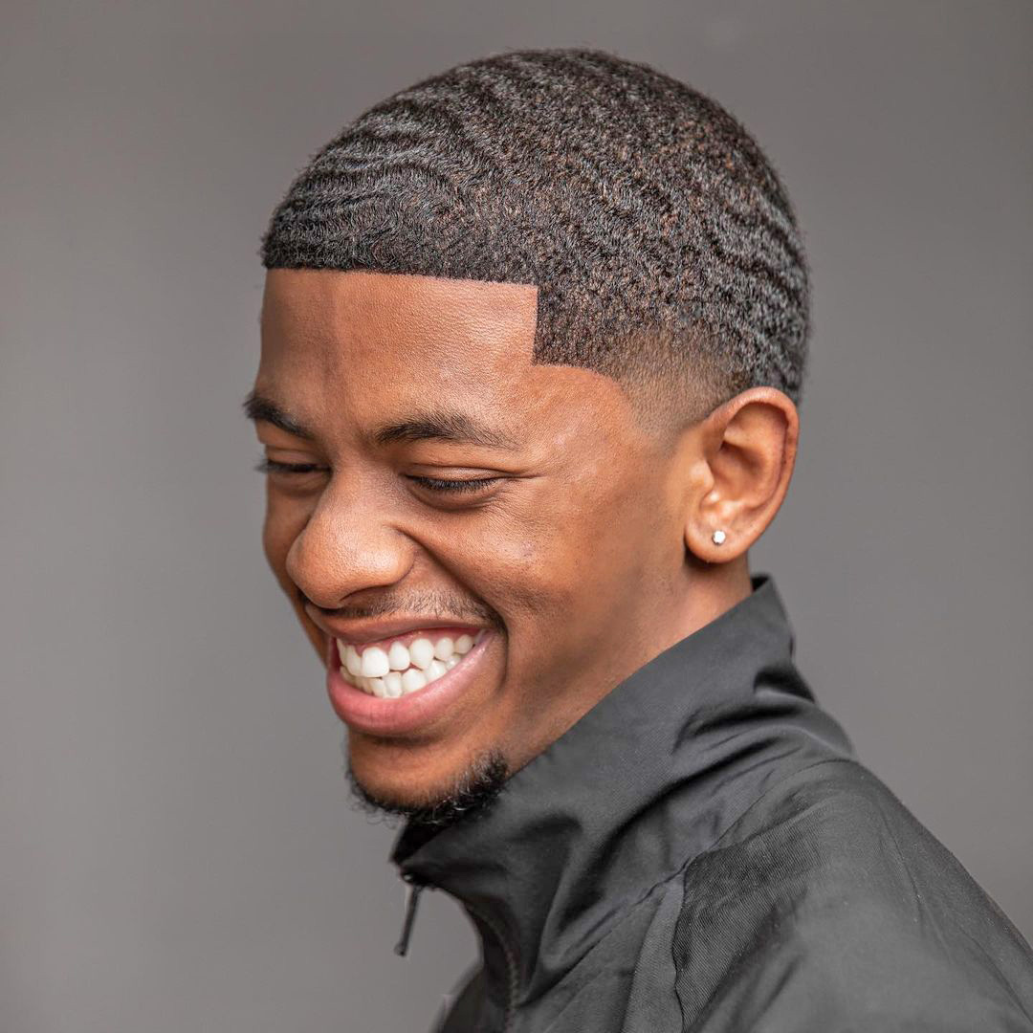

***UNEDITED IMAGE***

**EDITED PICTURE STEPS**

When a picture is edited, several processes might be applied to enhance, correct, or creatively alter the image. These processes can include:

* ***Colour Correction:*** Adjusting the brightness, contrast, saturation, and white balance to make the colours more accurate or visually appealing.
* ***Cropping:*** Trimming parts of the image to improve composition, remove distractions, or focus more closely on the subject.
* ***Retouching:*** Smoothing skin, removing blemishes, or correcting other imperfections in the image, such as dust spots or lens flare.
* ***Sharpening:*** Enhancing the clarity of the image by improving the edge definition, making details appear crisper.
* ***Noise Reduction:*** Reducing the graininess or visual noise, especially in low-light photographs, to create a cleaner image.
* ***Background Removal or Replacement:*** Changing or removing the background to isolate the subject or place it in a different context.
* ***Filters and Effects:*** Applying stylistic filters or special effects to create a particular mood or aesthetic, such as vintage looks, black and white, or HDR (High Dynamic Range).
* ***Resizing and scaling:*** Changing the dimensions of the image to fit specific formats or resolutions, often for print or online use.
* ***Text and Graphics Overlay:*** Adding text, logos, or other graphical elements to the image for branding, messaging, or design purposes.

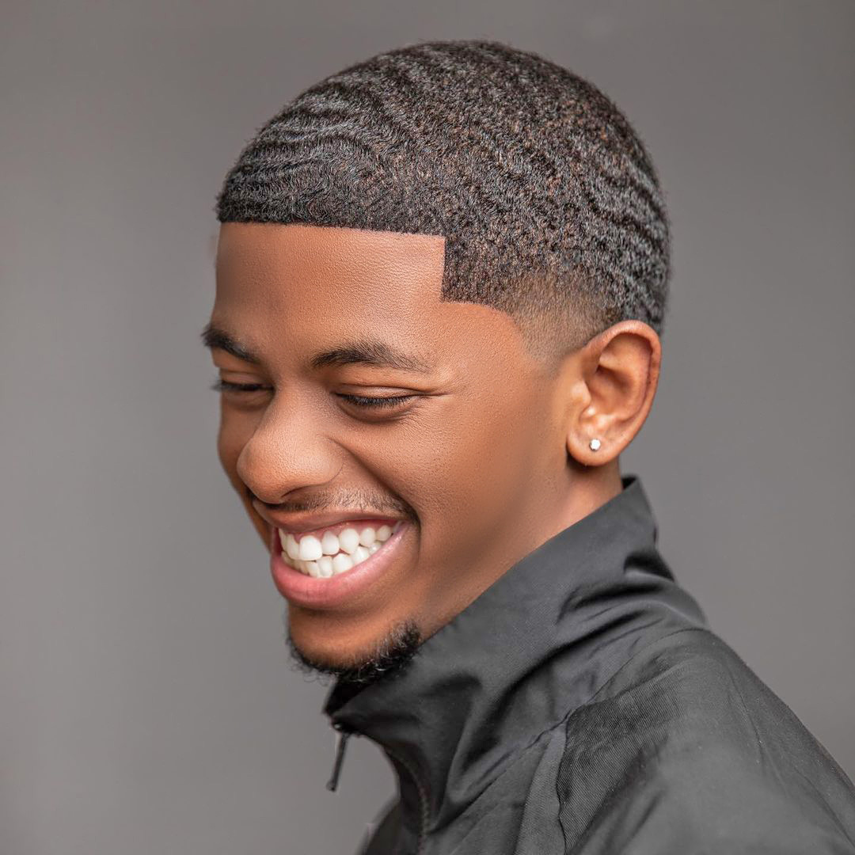

***EDITED IMAGE***

**CERTIFICATE OF IMAGE EDITING OBTAINED**

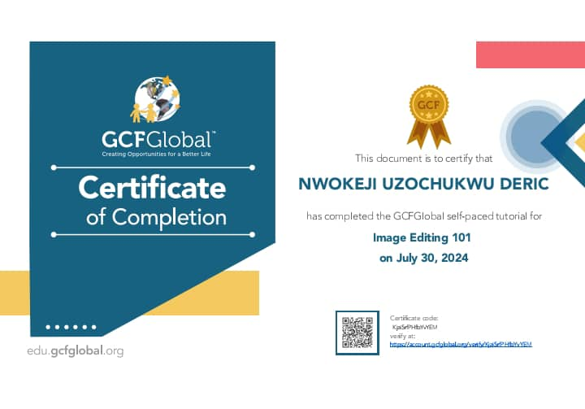

***AFTER***

***BEFORE***



